**23/11/2022**

**RESTful Web Services**

REST stands for REpresentational State Transfer.

REST is an architectural style not a protocol.

**Advantages of RESTful Web Services**

**Fast**

**Language and Platform independent**

**Permits different data format**

# Java Web Services

Java web service application perform communication through WSDL (Web Services Description Language). There are two ways to write java web service application code: SOAP and RESTful.

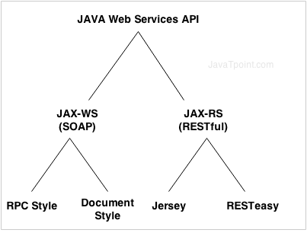

**REST Introduction**

**What is REST?**

The REST stands for **REpresentational State Transfer**.

Let's understand the meaning of each word in the REST acronym.

* **State** means data
* **REpresentational** means formats (such as XML, JSON, YAML, HTML, etc)
* **Transfer** means carrying data between consumer and provider using the HTTP protocol

**REpresentational State Transfer**

* REST was originally coined by Roy Fielding, who was also the inventor of the HTTP protocol.
* A REST API is an intermediary Application Programming Interface that enables two applications to communicate with each other over HTTP, much like how servers communicate to browsers.
* The REST architectural style has quickly become very popular over the world for designing and architecting applications that can communicate.
* The need for REST APIs increased a lot with the drastic increase of mobile devices. It became logical to build REST APIs and let the web and mobile clients consume the API instead of developing separate applications.

**2. REST Architecture**

The below diagram shows the typical REST architecture:

**[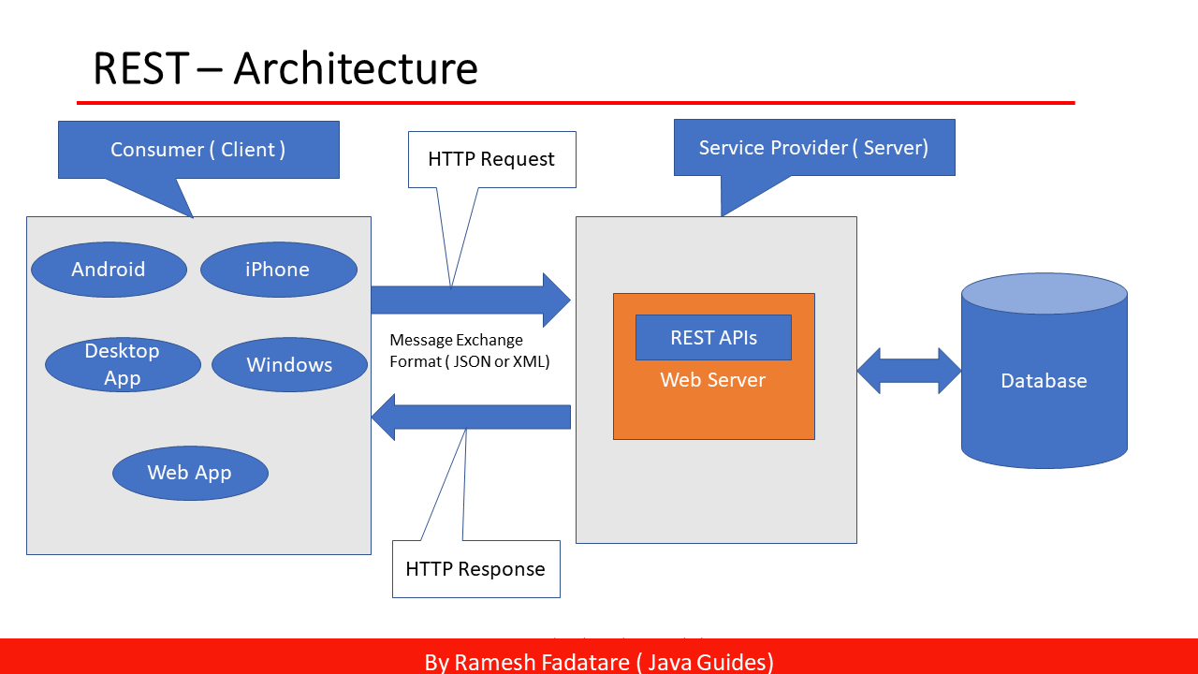](https://1.bp.blogspot.com/-tgigGwrUS_w/YERSui2Ha2I/AAAAAAAAInE/IB0uRSb0pQQwDNONFkFmdkHx6ksqS9NUQCLcBGAsYHQ/s1280/Slide4.PNG)**

Let's understand a few web service term's by looking into the above architecture:

**Request and Response:** Request is the input to a web service, and the response is the output from a web service.

**Message Exchange Format:**It is the format of the request and response. There are two popular message exchange formats: XML and JSON.

**Service Provider or Server:** The service provider is one that hosts the web service.

**Service Consumer or Client:**A service consumer is one who is using a web service.

It is the responsibility of the consumer means client application to prepare and send HTTP request message

It is the responsibility of the business component (developed by a service provider) to prepare and send the HTTP response message

**3. REST Architectural Constraints**

An API that has the following constraints is known as RESTful API:

**Client-server architecture:** The client is the front-end and the server is the back-end of the service. It is important to note that both of these entities are independent of each other.

**Stateless:** No data should be stored on the server during the processing of the request transfer. The state of the session should be saved at the client’s end.

**Cacheable:**The client should have the ability to store responses in a cache. This greatly improves the performance of the API.

**Uniform Interface:** This constraint indicates a generic interface to manage all the interactions between the client and server in a unified way, which simplifies and decouples the architecture.

**Layered System:**The server can have multiple layers for implementation. This layered architecture helps to improve scalability by enabling load balancing.

**Code on Demand:**This constraint is optional. This constraint indicates that the functionality of the client applications can be extended at runtime by allowing a code download from the server and executing the code.

**Restful Methods**

1. **POST** – This would be used to create a new employee using the RESTful web service
2. **GET** – This would be used to get a list of all employee using the RESTful web service
3. **PUT** – This would be used to update all employee using the RESTful web service
4. **DELETE** – This would be used to delete all employee using the RESTful services